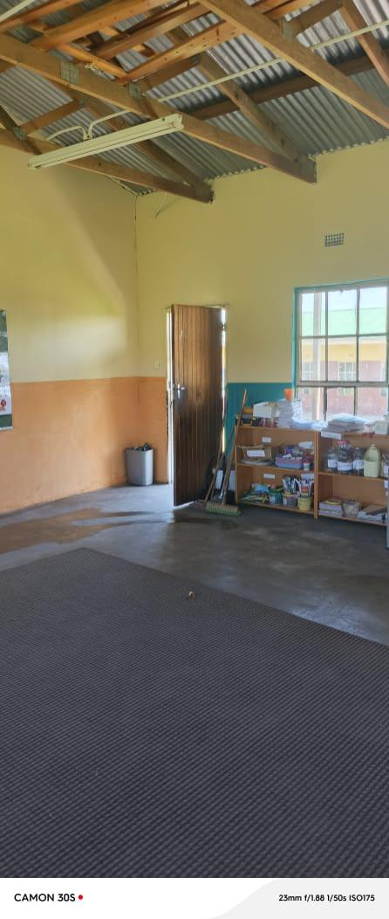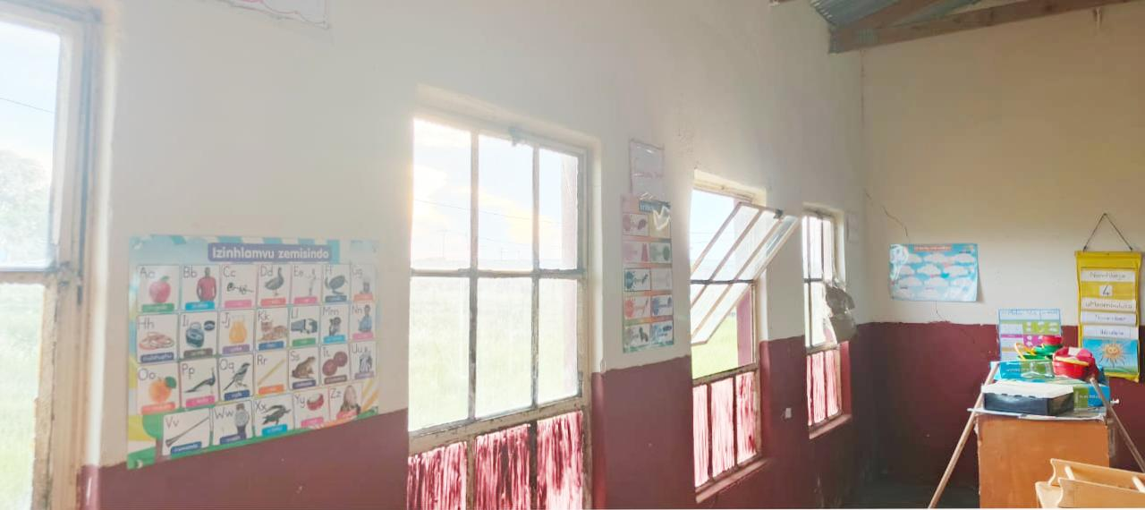before

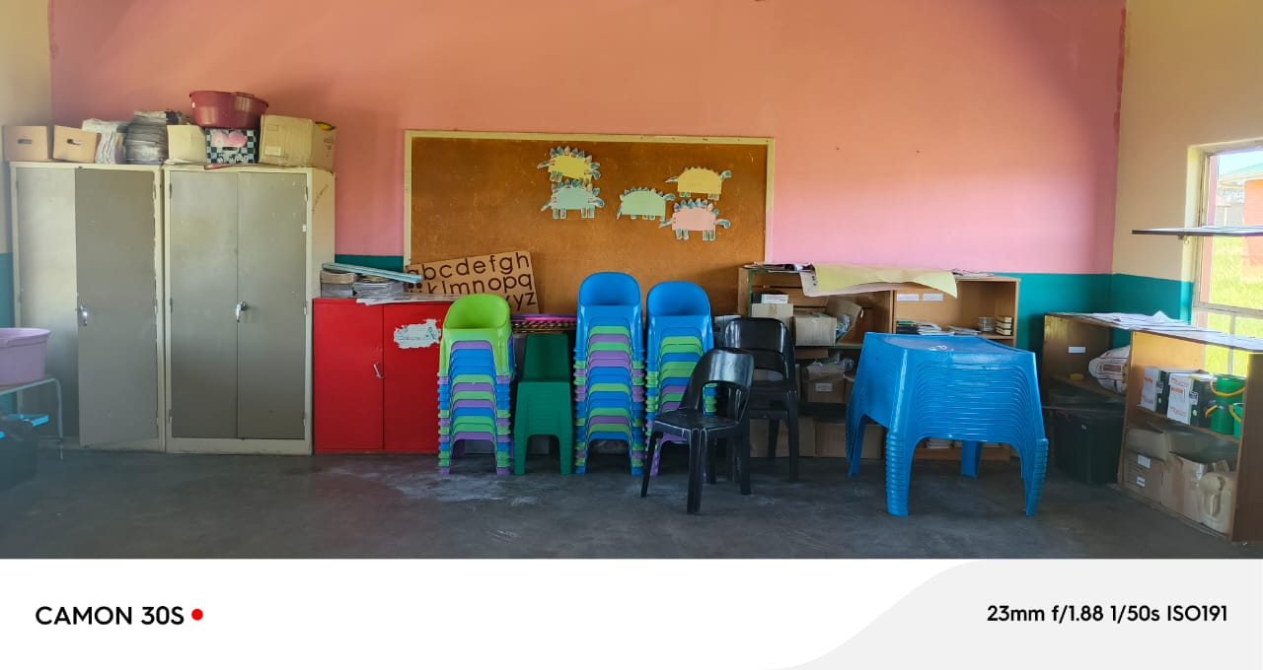as Sitinonke foundation we decided to surprise buhlebamangwe primary school grade R class by color painting their classroom we believe in putting a smile on our little faces ,we can’t wait to see the joy and happiness when the schools opens .a big thank you to Mr Buthelezi for opening his hands to grow his school as a new npo and also for the support to come and check on us as we were working .please do enjoy your class grade R